VIETNAM GENERAL CONFEDERATION OF LABOR
TON DUC THANG UNIVERSITY
FACULTY OF INFORMATION TECHNOLOGY

NGUYEN VIET ANH – 524H0003
TRAN HUU DANH – 524H0007
TA NGUYEN THANH QUY – 524H0124
LAM VI HOANG – 524H0088
COFFEE SHOP MANAGEMENT SYSTEM
FINAL REPORT
SOFTWARE ENGINEERING
Advised by
TS. Nguyễn Ngọc Phiên

HO CHI MINH CITY, 2026
ACKNOWLEDGEMENT
We would like to express our sincere gratitude to Dr. Nguyen Ngoc Phien, who directly supervised and wholeheartedly guided us throughout our studies and the execution of this project. With his profound knowledge and enthusiasm, he helped us overcome challenges and oriented our thinking to complete this report in the best possible way. Without his care and support, it would have been difficult for us to complete this task on time and achieve the expected results.
Ho Chi Minh city, .. September 20...
Author
(Signature and full name)

DECLARATION OF AUTHORSHIP
I hereby declare that this is my own research work, conducted under the scientific supervision of Dr. Nguyen Ngoc Phien. The research content and results presented in this project are truthful and have not been previously published in any form. The data in the tables used for analysis, commentary, and evaluation were collected by the author from various sources, which are clearly specified in the references section.
Furthermore, this Project also utilizes certain comments, assessments, and data from other authors and organizations, all of which are properly cited and referenced.
Should any academic fraud be discovered, I will take full responsibility for the content of my Project. Ton Duc Thang University bears no responsibility for any copyright or authorship violations committed by me during the execution of this project (if any).
Ho Chi Minh city, … September 20..
Author
(Signature and full name)

COFFEE SHOP MANAGEMENT SYSTEM
ABSTRACT
This project focuses on building a coffee shop management system to provide a comprehensive digital transformation solution, optimizing operational processes from table service to human resource management and customer care. Instead of fragmented management methods, the project digitizes the entire workflow, allowing store owners to easily control business operations in real-time and significantly minimize errors during ordering or payment. The system's strength lies in the balance between a seamless user experience and a highly secure information platform, ensuring customer data is always protected using the most advanced encryption technologies. With stable operation and flexible processing capabilities even during peak hours, the system not only improves employee productivity but also professionalizes the service, building trust and customer satisfaction, thereby laying a solid foundation for sustainable business expansion.
MỤC LỤC
CHƯƠNG 1. MỞ ĐẦU VÀ TỔNG QUAN ĐỀ TÀI 1
1.1 Mục đích. 1
1.2 Phạm vi. 1
1.3 Từ điển thuật ngữ. 1
1.4 Tài liệu tham khảo. 1
1.5 Tổng quát. 2
1.5.1 Nhân sự 2
1.5.2 Quản lý Menu 2
1.5.3 Quản lý Kho 2
1.5.4 Hoạt động bán hàng 2
1.5.5 Thanh toán 3
1.5.6 Quy trình nhận đồ uống (Take-away tại quầy) – Cần thảo luận và chỉnh sửa 3
1.5.7 Quy trình nhận đồ uống (Order qua QR tại bàn) 3
1.5.8 Đặt hàng trước 3
1.5.9 Đặt bàn và Dịch vụ khác 3
1.5.10 Đánh giá và Truyền thông 4
CHƯƠNG 2. CÁC YÊU CẦU CHỨC NĂNG 4
2.1 Các tác nhân. 4
2.2 Các chức năng của hệ thống. 4
2.3 Biểu đồ use case tổng quan. 6
2.4 Biểu đồ use case phân rã. 6
2.5 Quy trình nghiệp vụ. 6
2.5.1 Quy trình đăng ký tài khoản 6
2.5.2 Quy trình đăng nhập đăng xuất 8
2.5.3 Quy trình quản lý hồ sơ, đổi mật khẩu 9
2.5.4 Quy trình đặt món 10
2.5.5 Quy trình giỏ hàng và thanh toán 11
2.5.6 Quy trình hệ thống thành viên 11
2.5.7 Quy trình đánh giá 12
2.5.8 Quy trình điều phối đơn 13
2.5.9 Quy trình quản lý bàn 14
2.5.10 Quy trình chấm công 16
2.5.11 Quy trình quản lý lịch trình 16
2.5.12 Quy trình quản lý thực đơn và combo 18
2.5.13 Quy trình quản lý kho và định mức 19
2.5.14 Quy trình phân quyền và duyệt lịch làm việc 19
2.5.15 Quy trình thống kê và phân tích 20
2.5.16 Quy trình quản lý khuyến mãi 21
2.6 Đặc tả các usecase. 22
2.6.1 Đăng kí tài khoản 22
2.6.2 Đăng nhập đăng xuất 24
2.6.3 Quản lý hồ sơ, đổi mật khẩu 25
2.6.4 Đặt món 27
2.6.5 Giỏ hàng và thanh toán 28
2.6.6 Hệ thống thành viên 30
2.6.7 Đánh giá 32
2.6.8 Điều phối đơn 33
2.6.9 Quản lý bàn 35
2.6.10 Chấm công 36
2.6.11 Quản lý lịch trình 37
2.6.12 Quản lý thực đơn và combo 39
2.6.13 Quản lý kho và định mức 40
2.6.14 Phân quyền và duyệt lịch làm việc 42
2.6.15 Thống kê và phân tích 43
2.6.16 Quản lý khuyến mãi 45
CHƯƠNG 3. CÁC YÊU CẦU PHI CHỨC NĂNG 46
TÀI LIỆU THAM KHẢO 47

INTRODUCTION AND PROJECT OVERVIEW

Objectives.
The primary objective of this project is to develop and deploy a coffee shop management system aimed at comprehensively modernizing operational workflows and enhancing practical business efficiency. By digitizing activities ranging from order taking and transaction processing to customer information management, the project seeks to minimize manual errors, optimize staff productivity, and reduce customer wait times. Furthermore, the system focuses on establishing a robust, secure, and stable management platform, enabling business owners to easily manage resources and make accurate, data-driven business decisions. Consequently, the project not only addresses day-to-day operational challenges but also delivers a sustainable technological solution, contributing to the professionalization of services and readiness for future scalability.

Project Scope.
The scope of this project focuses on developing a management system for a coffee shop specializing in a take-away model at a single location. The system digitizes table map management by assigning unique identifiers to each seating position and recording the corresponding number of seats. Simultaneously, it integrates quick-response mechanisms, enabling customers to proactively access the menu and place orders on the spot. Instead of adopting a traditional table service workflow, the project utilizes data from these identifiers to accurately pinpoint the origin of an order, thereby effectively supporting table clearing tasks and tracking operational productivity metrics. This solution synchronizes the data flow from order reception to transaction completion, ensuring an accurate, transparent operational process and optimizing customer service time.

Glossary.

References.

Overview.

Personnel
The system is designed to support a lean and versatile workforce, consisting of two main roles: managers and staff. The staff are cross-trained to handle multiple tasks simultaneously, ranging from cashiering and order reception at the counter to bartending and drink preparation at the pickup area. Integrating these skills allows the coffee shop to optimize resources and easily coordinate tasks based on customer traffic at any given time, without being constrained by specialized positions. Each employee is issued a unique identifier to perform operations on the software, ensuring transparent accountability and transaction management. Notably, staff focus entirely on counter operations and do not provide table service, guaranteeing rapid order processing times aligned with the characteristics of the take-away model.

Menu Management
The system manages the catalog of items on the menu. Each item includes an item code, name, unit price, category, and recipe. The recipe details the required amount of ingredients for each drink. The menu is applied globally across the shop and can be administered by the manager.

Inventory Management
The coffee shop manages ingredients and inventory supplies such as coffee, milk, sugar, and related materials. Each ingredient is tracked using an ingredient code, name, current stock quantity, and an alert threshold. Inventory levels are updated when staff restock items or when ingredients are consumed to prepare drinks according to their recipes.

Sales Operations
Sales operations are managed through orders. Orders can be created by staff (at the counter) or independently by customers (via the web platform or by scanning a QR code). An order consists of one or multiple items, with each item specifying the quantity, unit price, size, and additional customizations (such as sugar level, ice level, and creaminess).

Payment Processing
Each order cycles through various statuses: newly created, preparing, ready (awaiting pickup), completed, or canceled. Orders can be paid for using e-wallets, bank transfers, or cash. Payment information is securely stored and uniquely linked to the respective order.

Drink Pickup Process
Customers proactively select items and process payments directly via the mobile app, completely eliminating the need to queue at the counter. Once an order is placed, the app tracks the preparation progress in real-time and triggers a vibration or ring notification directly to the phone as soon as the drink is ready. Customers simply proceed to the pickup area and present the confirmation screen on the app to collect their order, creating a modern, fast, and seamless self-service workflow.

Advance Ordering (Pre-ordering)
Customers can proactively place remote orders and make payments via the app, while selecting a specific pickup time to optimize their personal schedules. All preparation stages are updated directly on the mobile device, allowing customers to arrive at the designated time and head straight to the pickup area. Relying on the completion notification and the confirmation code displayed on the app, customers can independently collect their properly packaged orders without enduring any wait times or completing additional check-in procedures at the counter.

Table Reservation
Customers can proactively select seating locations, the number of seats, and accompanying amenities (such as projectors or TVs) directly on the mobile app to suit their specific needs. Based on the seat count and the lowest item price on the menu, the app automatically calculates and requests an online deposit to secure the reservation for the selected time slot. All details regarding the booking schedule and table status are communicated directly to the phone; however, customers will still follow the standard self-service procedure at the counter to collect their drinks.

Feedback and Communication
Upon completing their experience, customers can directly share their feedback and rate the service quality through the mobile app interface. These reviews not only assist the management in improving operational processes but are also aggregated by the system to deliver personalized loyalty programs and promotions directly to the customers' phones. Through the app, patrons remain continuously connected and updated on the latest beverage trends, transforming each review into an effective and modern two-way communication channel.

FUNCTIONAL REQUIREMENTS

System Actors.
- Customer
- Staff
- Manager
- Software System
- Payment System

System Functions
The list of features is categorized by user groups:
Customer Features:
- Account Management: Register / Login / Logout, User Profile, Change Password.
- Ordering: Table ordering (Scan QR code at the table); Remote ordering (Scheduled pickup, Scheduled delivery); Item customization (Toppings, sugar/ice levels, special notes).
- Cart & Payment: Cart management (Increase/decrease quantity, remove items, view total items and price); Multi-modal payment (Cash, e-wallets, QR banking, card swipe/POS); Invoice issuance (Standard receipt, VAT/Red invoice).
- Membership System: Accumulate points for rewards, Membership tiers, Vouchers.
- Reviews & Ratings: Submit star ratings / food photos, View / write sharing posts (blog).
- Other Functions: Order history, Order status notifications.

Staff Features:
- Operations Management: Coordination dashboard (real-time order reception, displaying recipes and additional customer requests).
- Table Management: Table status tracking (empty, occupied, awaiting clearing, reserved), Table transfer, Bill merging.
- Payment & Invoicing: Payment confirmation, Print invoices (Standard receipt, VAT/Red invoice).
- Personal Management: Time and attendance (Check-in/out via QR); Scheduling (Register for shifts, cancel shift registration — cancellation not allowed after 15 minutes, view schedule, request leave/time-off).

Manager Features:
- Menu Management: CRUD (Create, Read, Update, Delete) operations for items, combos, and categories; Status customization (in stock / temporarily out of stock).
- Inventory & Quota Management: Ingredient quotas (Standard recipes); Import / Export inventory (Supplier management, periodic inventory checks, low stock alerts).
- Staff Management: Role assignment/authorization (Cashier, barista, server); Master schedule arrangement, Leave approval.
- Promotion Management: Create discount codes, Discount programs / campaigns.
- Analytics & Reporting: Revenue reports (daily/monthly/yearly), Profit reports (after deducting costs); Best-selling items statistics, Peak hours analysis.

Overview Use Case Diagram.
QUÝ

Decomposition Diagram.
QUÝ

Business Processes.

Account Registration Process
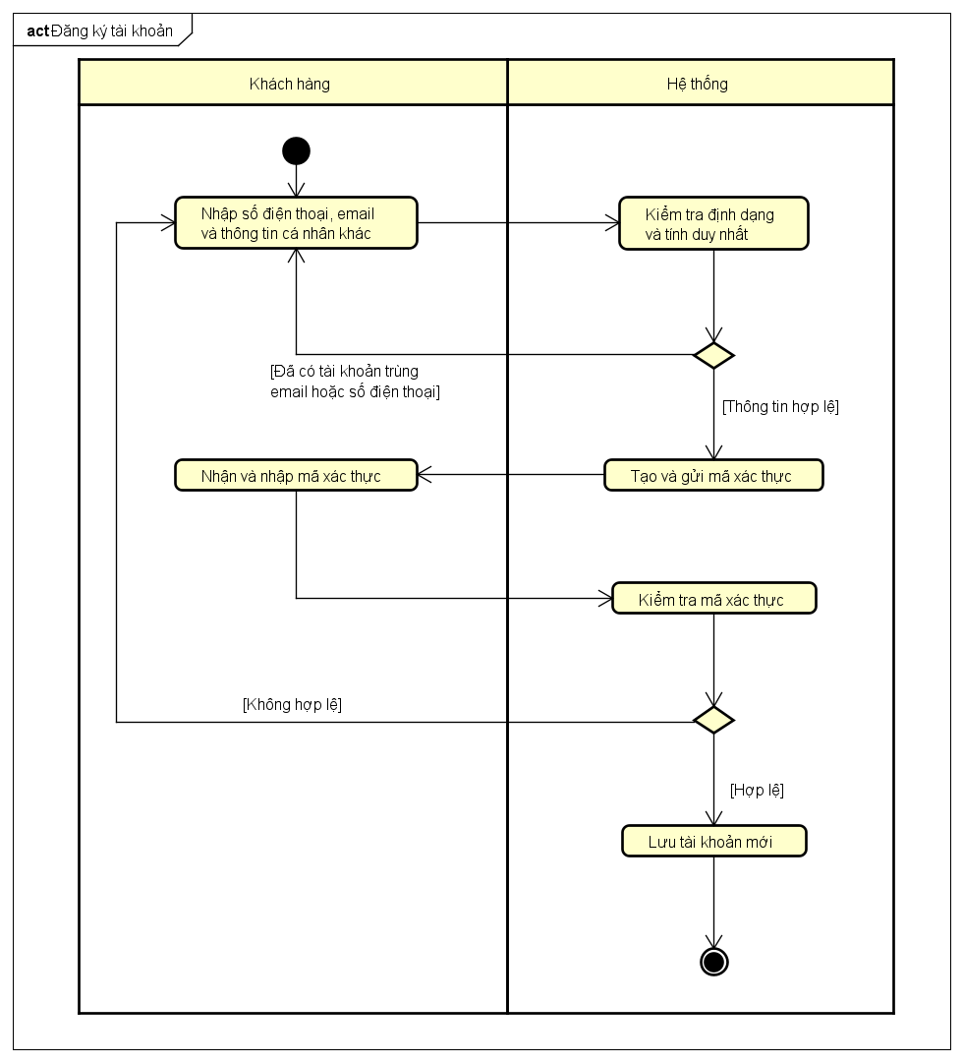

Field | Details
Use Case Name | Account Registration
Scenario | A new customer creates an account to accumulate reward points and save order history.
Triggering event | The customer clicks the "Register" (or "Sign Up") button on the welcome screen or during checkout.
Brief description | Allows users to create a new account using their phone number or email address.
Actors | Customer.
Preconditions | The customer does not currently have an account in the system.
Post conditions | The account is successfully created, and the user is automatically logged into the system.
Flow of activities (Actor) | 1. Enters phone number/email and other required information.  2. Enters the OTP verification code.  3. Completes the registration process.
Flow of activities (System) | 1. Validates the data format and account uniqueness.  2. Sends the OTP verification code.  3. Encrypts the password and saves the account to the database.  4. Displays a successful registration notification.
Exception conditions | - Phone number/Email already exists: The system prompts the user to log in or use different credentials.  - Invalid or expired OTP: The system prompts the user to request a new verification code.

Account Login Process
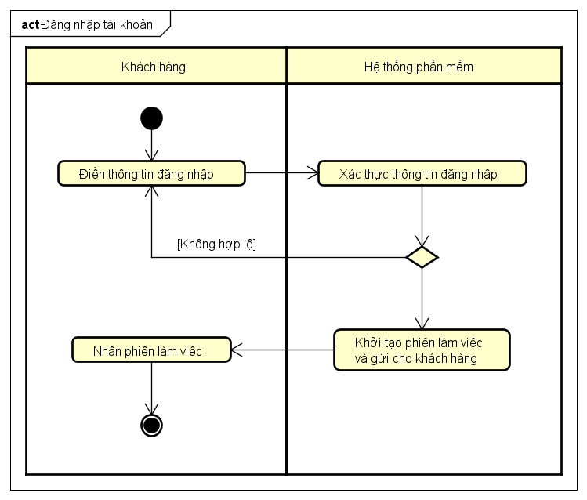
Field | Details
Use Case Name | Login
Scenario | A customer accesses their personal account to place an order.
Triggering event | The customer opens the app and needs to use a feature that requires logging in.
Brief description | Authenticates the user's identity to access personalized features.
Actors | Customer
Preconditions | The customer has a valid, existing account.
Post conditions | The account is successfully authenticated, and the user is logged in.
Flow of activities (Actor) | 1. Enters login credentials (Phone number/Email) and password.  2. Submits the login information.
Flow of activities (System) | 1. Validates the login credentials.  2. Initializes the user session.
Exception conditions | - Incorrect username/password: The system displays an error message and prompts the user to re-enter their credentials.

Profile Management and Password Change Process
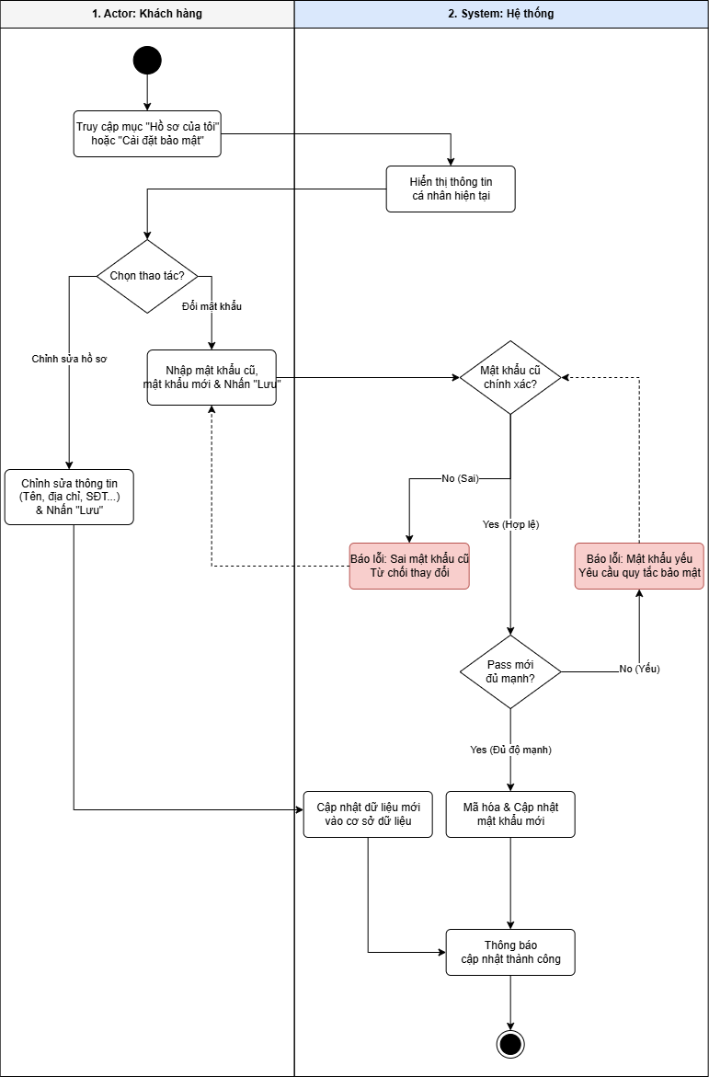

Ordering Process
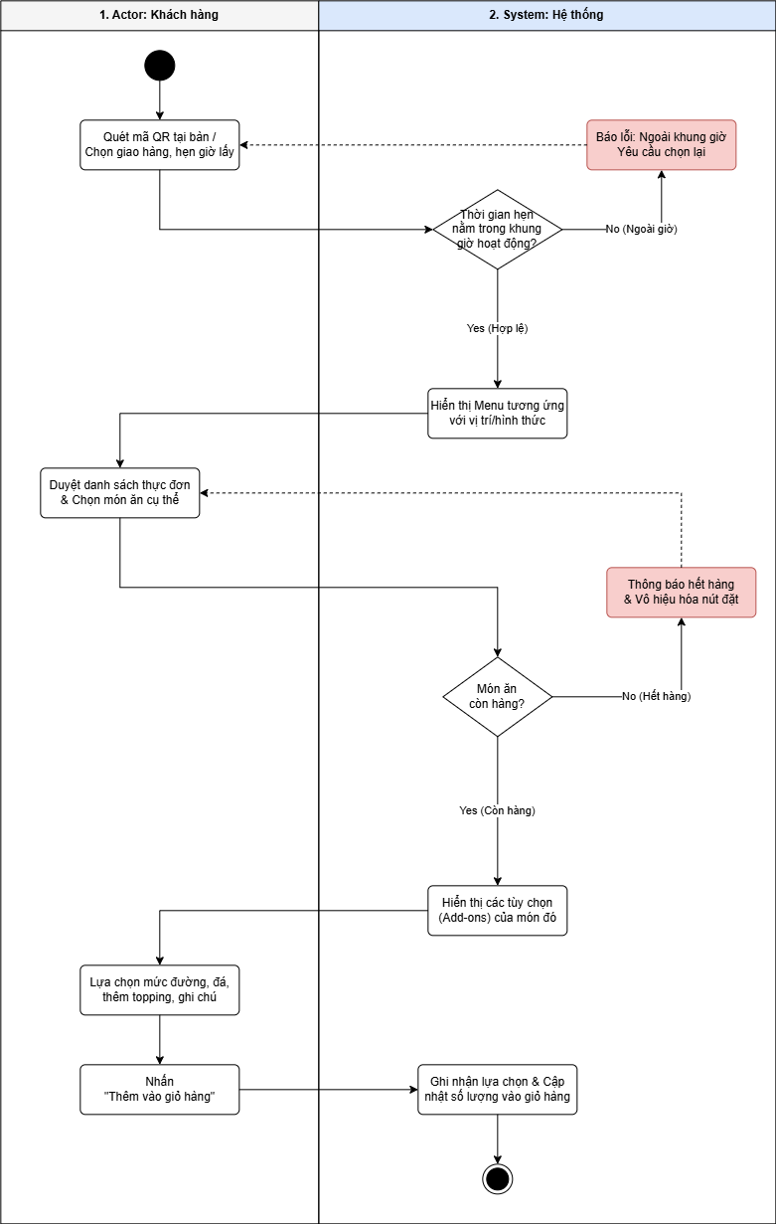

Cart and Checkout Process
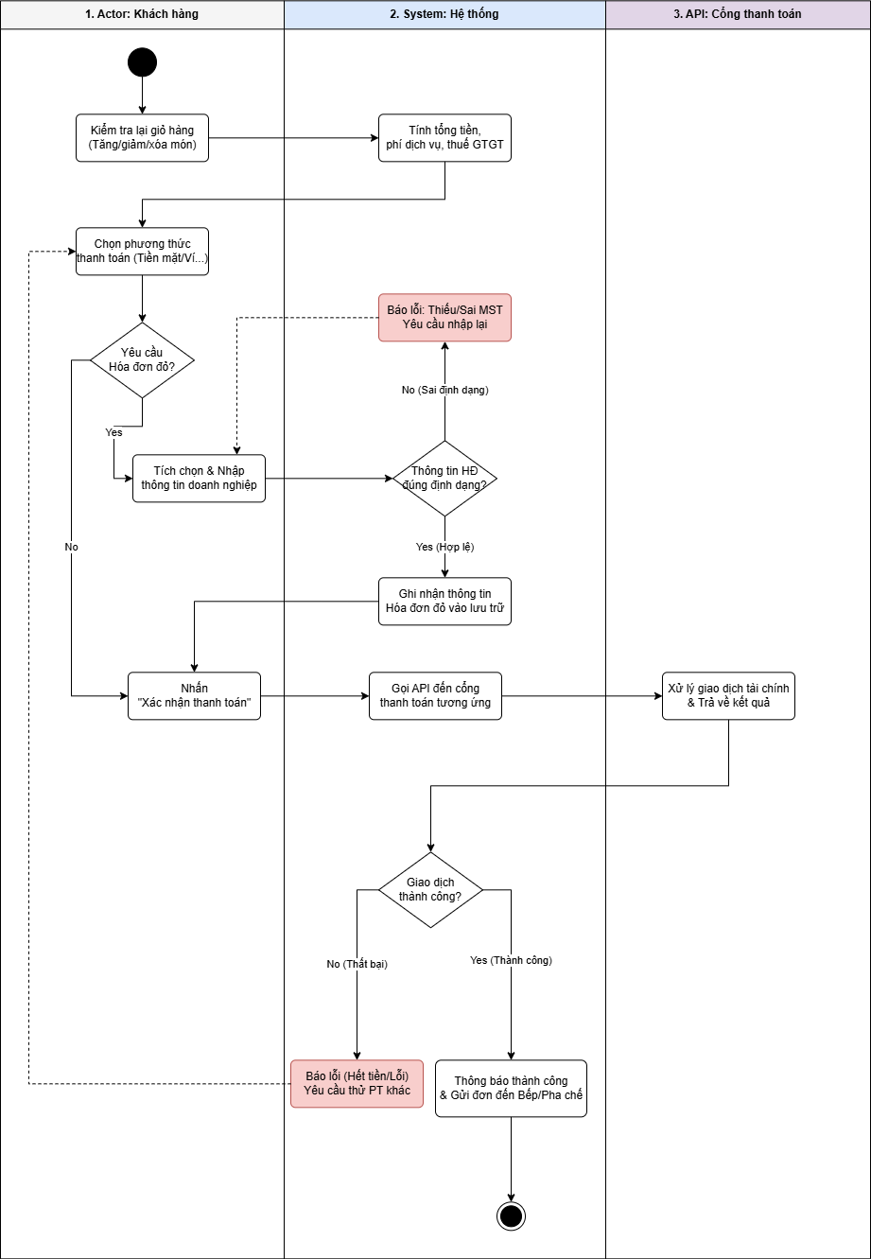

Membership and Loyalty Process
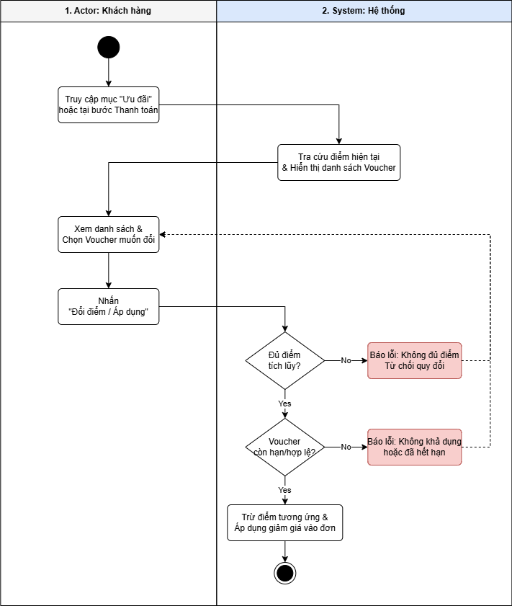

Review and Rating Process
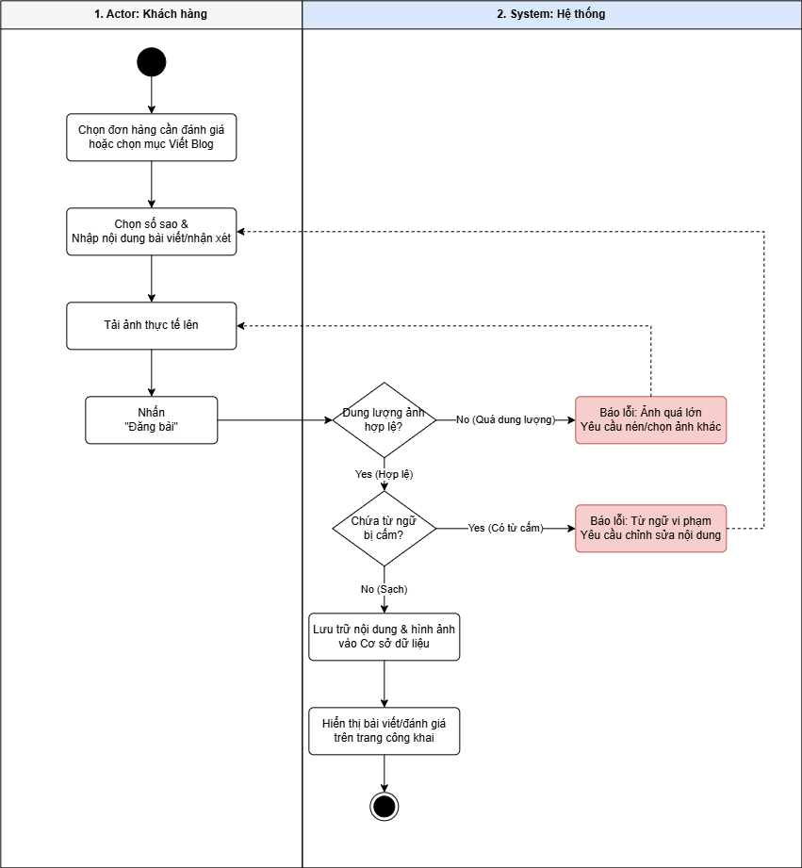

Order Coordination Process
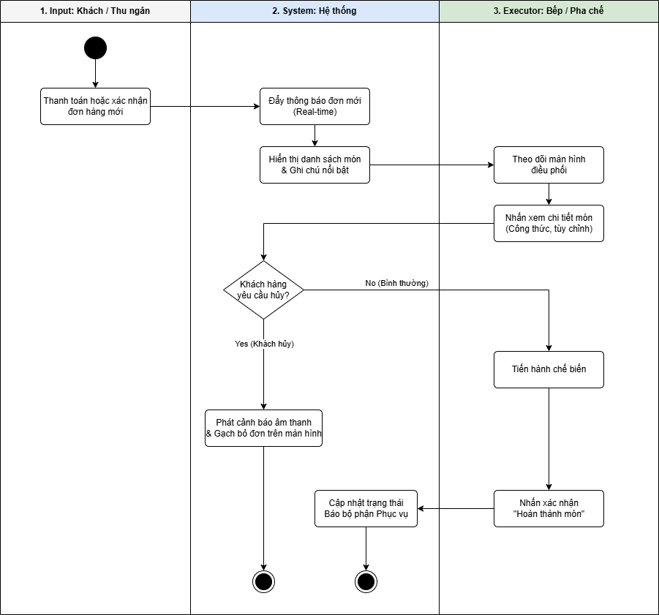

Table Management Process
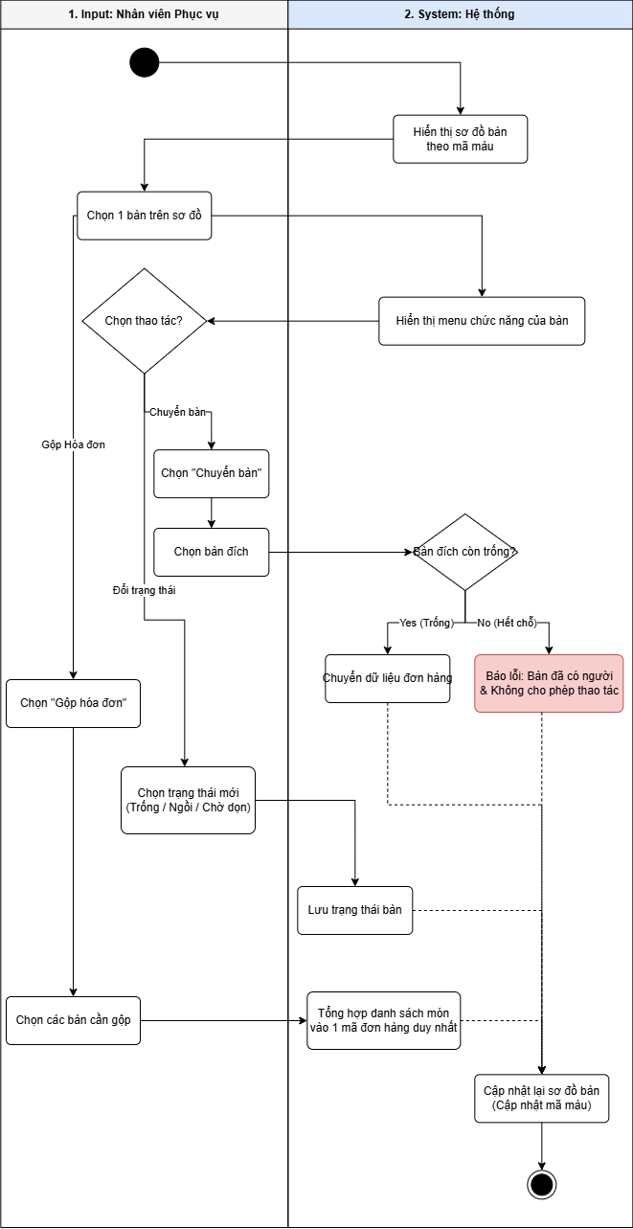

Time and Attendance Process
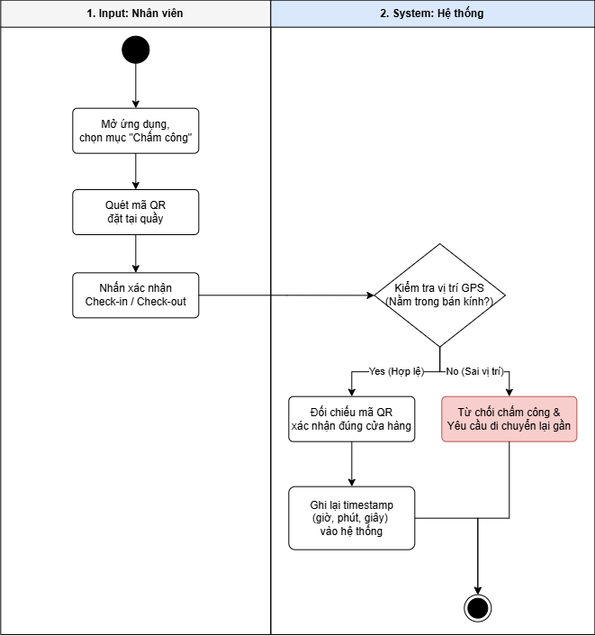

Schedule Management Process
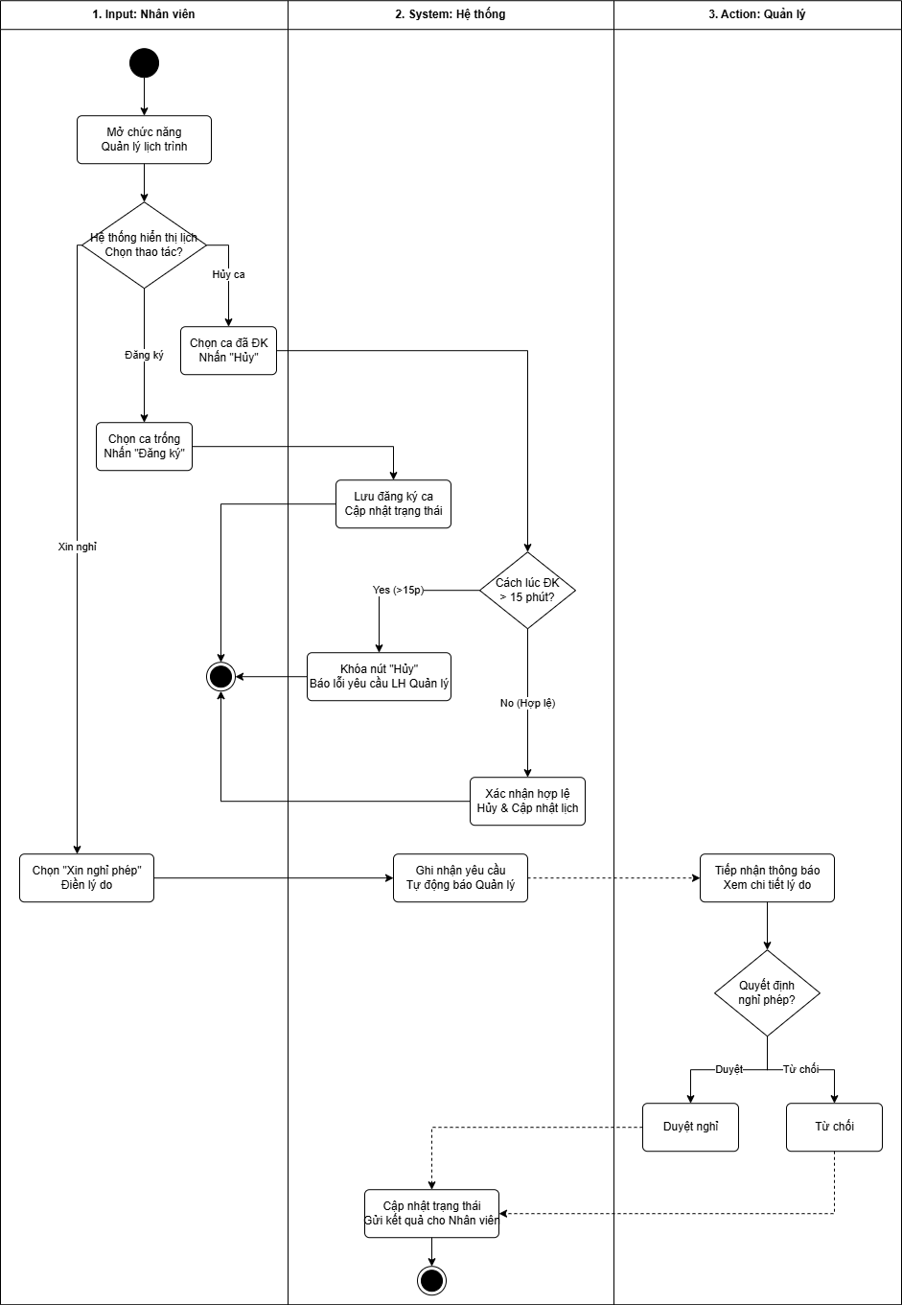

Menu and Combo Management Process
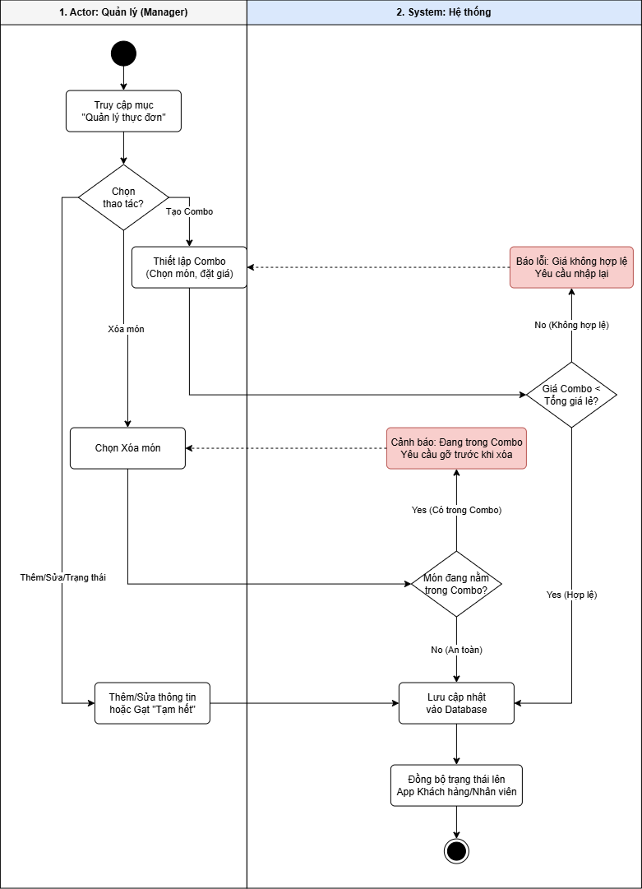

Inventory and Quota Management Process
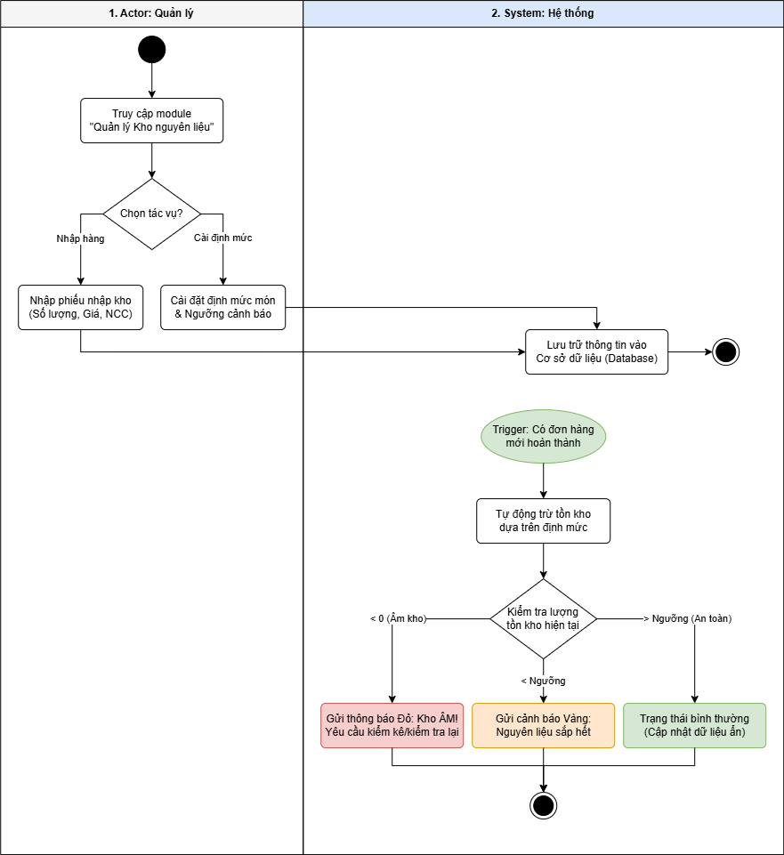

Role Assignment and Schedule Approval Process
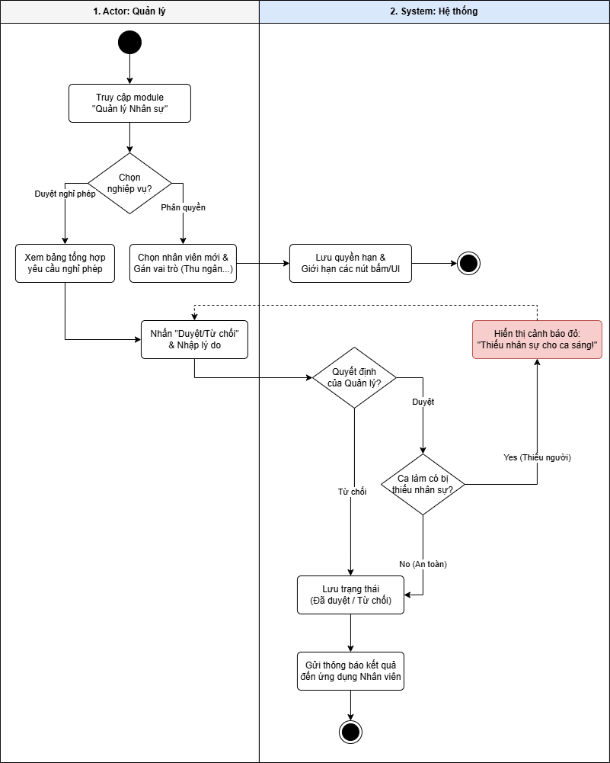

Reporting and Analytics Process
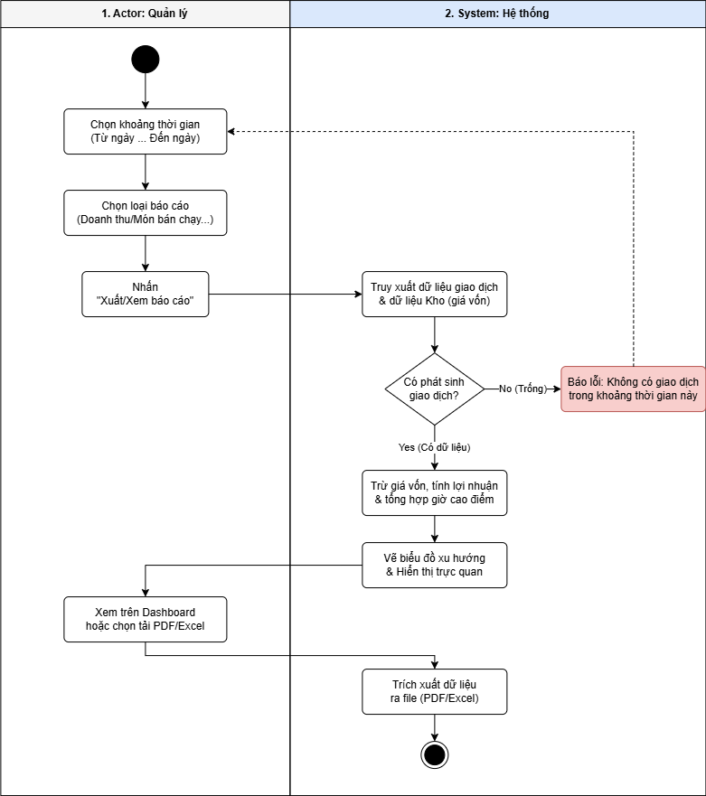

Promotion Management Process
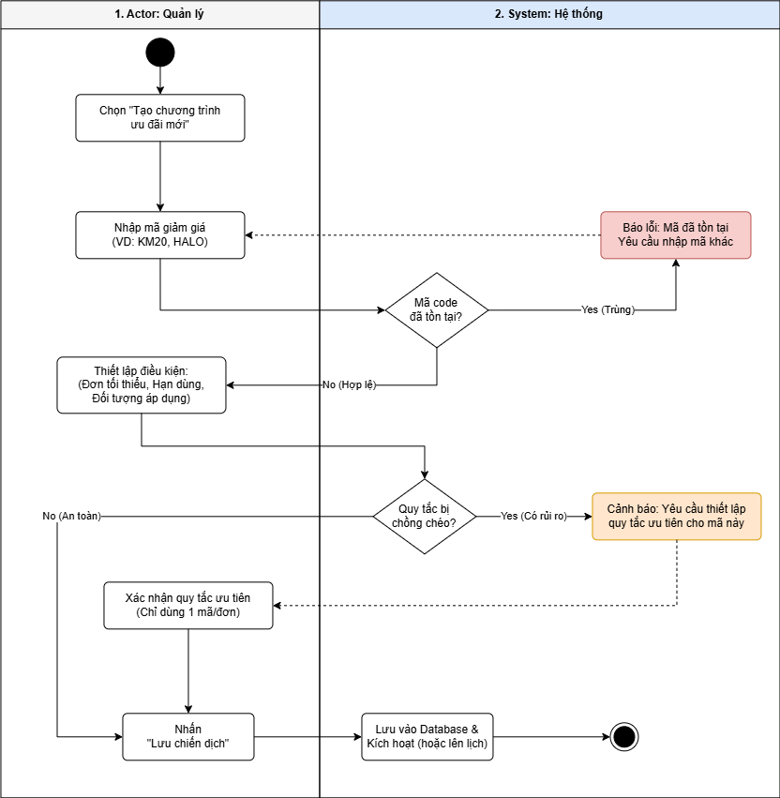

Use Case Descriptions.

Login and Logout

Profile Management and Password Change
Field | Details
Use Case Name | Profile and Security Management
Scenario | Customer updates personal information or changes password periodically.
Triggering event | Customer accesses the "My Profile" or "Security Settings" section.
Brief description | Allows changing contact information, avatar, and updating a new password.
Actors | Customer
Preconditions | Customer is logged into the system.
Post conditions | Personal information or new password is updated.
Flow of activities (Actor) | 1. Select "Edit Profile" or "Change Password".  2. Change the necessary information (Name, address, old/new password).  3. Click "Save Changes".
Flow of activities (System) | 1. Display current user information.  2. Validate the old password (if changing the password).  3. Update the new data in the system.
Exception conditions | - Incorrect old password: Do not allow changing to a new password.  - New password is not strong enough: Request to re-enter according to security policies.

Ordering Process
Field | Details
Use Case Name | Ordering and Customization
Scenario | Customer selects items, customizes attributes (sugar, ice, toppings), and chooses a receiving method (at table or scheduled).
Triggering event | Customer scans the QR code at the table or opens the app to order remotely.
Brief description | Allows customers to view the menu, select items, add notes/toppings, and add them to the cart.
Actors | Customer
Preconditions | Customer has accessed the system/application.
Post conditions | Items are successfully added to the cart with full customization details.
Flow of activities (Actor) | 1. Scan QR code (at table) or select "Delivery/Pick up at store".  2. Browse the menu list.  3. Select a specific item.  4. Choose sugar/ice levels, add toppings, or write notes.  5. Click "Add to Cart".
Flow of activities (System) | 1. Display the menu corresponding to the location (or online menu).  2. Display the options (Add-ons) for that item.  3. Check item availability (in stock/out of stock).  4. Record selections and update temporary quantity in the cart.
Exception conditions | - Item out of stock: System displays a notification and disables the order button.  - Scheduling outside operating hours: System requests selecting a different time.

Cart and Checkout
Field | Details
Use Case Name | Multi-method Payment & Invoicing
Scenario | Customer reviews the cart, selects a payment method, and requests a red invoice (VAT invoice) if needed.
Triggering event | Customer clicks the "Checkout" button from the cart.
Brief description | Processes the final item quantities, applies vouchers, calculates the total amount, and executes the financial transaction.
Actors | Customer, Payment System (Bank/E-wallet), Accountant (if red invoice is requested).
Preconditions | The cart contains at least one item.
Post conditions | Transaction is successful, the order is sent to the barista, and the invoice is generated.
Flow of activities (Actor) | 1.Review the item list (increase/decrease/delete).  2. Select payment method (Cash/E-wallet/QR/Card).  3. Check "Request red invoice" and fill in corporate details (if any).  4. Confirm payment.
Flow of activities (System) | 1. Calculate total amount, service fees, and VAT.  2. Call the API of the corresponding payment gateway.  3. Record red invoice information into the storage system.  4. Notify transaction result and print invoice/send notification to the kitchen.
Exception conditions | - Transaction failed (Insufficient funds, network error): System reports the error and allows trying another method.  - Invalid red invoice format (Missing Tax ID): System requests re-entry.

Membership System

Reviews and Ratings
Field | Details
Use Case Name | Review & Share Post
Scenario | Customer submits feedback after experiencing the service or writes a blog post to share delicious dishes.
Triggering event | Order is completed or the customer actively accesses the Blog section.
Brief description | Submit star ratings, actual photos, and long-form content to the system.
Actors | Customer
Preconditions | Customer has used the service (for item reviews) or has an account (for Blog posts).
Post conditions | The post/review is displayed publicly or sent to the administrator.
Flow of activities (Actor) | 1. Select the order/item to review.  2. Choose the star rating and upload actual photos.  3. Enter the feedback content or write a blog post.  4. Click "Post".
Flow of activities (System) | 1. Store content and images in the Database.  2. Moderate sensitive language (if a filter is active).  3. Display the review on the item information page or the general Blog page.
Exception conditions | - Uploaded photo exceeds size limit: System requests image compression or selecting another photo.  - Contains prohibited language: System requests content editing.

Order Coordination
Field | Details
Use Case Name | Order Receiving & Coordination
Scenario | Kitchen staff views the list of items to be prepared, recipes, and special notes from customers.
Triggering event | A new order is paid or confirmed by the Customer/Cashier.
Brief description | Displays the list of items in real-time chronological order, including preparation instructions and customer customizations.
Actors | Kitchen/Barista Staff
Preconditions | The system is in active status (Online).
Post conditions | Items are marked as "Completed" and transferred to the service department.
Flow of activities (Actor) | 1. Monitor the coordination screen to receive new orders.  2. Click on an item to view recipe details/notes (e.g., less sugar, no ice).  3. After preparation, click confirm "Item Completed".
Flow of activities (System) | 1. Push new order notifications in real-time.  2. Highlight customization information (Toppings, sugar/ice levels) on the screen.  3. Update the order status for the customer and service staff.
Exception conditions | Order cancelled by customer: System triggers an audio alert and strikes through the order on the coordination screen.

Table Management
Field | Details
Use Case Name | Table Status & Invoice Coordination
Scenario | Staff changes table status, moves customers to a new table, or merges orders into a single invoice.
Triggering event | Customers arrive, request a seat change, or request a combined payment.
Brief description | Manages the lifecycle of a table from the moment a customer books it until cleaning is completed.
Actors | Service Staff
Preconditions | Staff has logged into the management system.
Post conditions | Table status is accurately updated on the floor plan.
Flow of activities (Actor) | 1. Select a table on the floor plan.  2. Update status (Vacant -> Occupied -> Pending Cleaning).  3. Perform "Move Table" or "Merge Invoices" operations if requested by the customer.
Flow of activities (System) | 1. Display the table floor plan with color coding (e.g., Red - Occupied, Green - Vacant).  2. When merging invoices: Consolidate the item lists from selected tables into a single order ID.
Exception conditions | Moving customers to an occupied table: System reports an error and denies the operation.

Attendance Tracking
Field | Details
Use Case Name | QR Code Attendance
Scenario | Employees perform Check-in/Check-out at the beginning and end of their shifts.
Triggering event | Employee arrives at the store or is about to leave.
Brief description | Uses a phone camera to scan a QR code placed at the store to record working hours.
Actors | Employee
Preconditions | Phone has an internet connection and GPS location enabled (to ensure presence at the store).
Post conditions | Time data is recorded in the timesheet.
Flow of activities (Actor) | 1. Open the employee app and select "Attendance".  2. Scan the QR code placed at the counter.  3. Confirm Check-in/Check-out.
Flow of activities (System) | 1. Check the employee's GPS location (must be within the store's radius).  2. Verify the QR code to confirm the correct store.  3. Record the timestamp (hour, minute, second) into the system.
Exception conditions | Incorrect GPS location: System rejects the attendance and requests the employee to move closer to the store.

Schedule Management
Field | Details
Use Case Name | Shift Registration & Schedule Adjustment
Scenario | Employees register for work shifts or apply for leave according to regulations.
Triggering event | The start of a new weekly schedule registration period or an unexpected event requiring a shift cancellation.
Brief description | Allows employees to self-manage their working hours based on system constraints.
Actors | Employee
Preconditions | Employee account is in active status.
Post conditions | The work schedule is updated or the leave request is sent to the Manager.
Flow of activities (Actor) | 1. View the schedule of available empty shifts.  2. Click "Register" for a shift.  3. To cancel: Select a registered shift and click "Cancel".  4. To apply for leave: Select the date and fill in the reason.
Flow of activities (System) | 1. Check cancellation conditions: If the current time is > 15 minutes after the registration time, lock the "Cancel" button.  2. Send the leave request notification to the Manager's account.
Exception conditions | Exceeded 15-minute limit: System displays a notification: "The time allowed to self-cancel the shift has expired, please contact the Manager directly."

Menu and Combo Management
Field | Details
Use Case Name | Menu, Combo & Item Status Management
Scenario | Manager adds new items, creates Combo packages, or updates status to "Out of Stock" when inventory is depleted.
Triggering event | New items arriving, price changes, or staff reporting out-of-stock ingredients.
Brief description | Performs CRUD operations (Create, Read, Update, Delete) for categories, individual items, and discounted combo packages.
Actors | Manager
Preconditions | Manager has successfully logged into the Admin Dashboard.
Post conditions | The menu on the Customer and Staff applications is updated immediately.
Flow of activities (Actor) | 1. Select "Menu Management".  2. Add/Edit item information (name, price, image, category).  3. Set up Combo: select component items and set a promotional price.  4. Toggle the "Out of Stock" switch if the item needs to be discontinued temporarily.
Flow of activities (System) | 1. Store information in the Database.  2. Synchronize item status to the Customer's ordering interface (QR/App).  3. Validate Combo price (must be lower than the total price of individual items).
Exception conditions | Deleting an item that is part of a Combo: System warns and requires removing the item from the Combo before deletion.

Inventory and Recipe Management
Field | Details
Use Case Name | Inventory & Stock Level Alert Management
Scenario | Manager imports goods from suppliers, sets consumption norms (e.g., 1 cup of coffee uses 20g of beans), and receives alerts when stock is running low.
Triggering event | New goods arrive or stock levels reach the minimum threshold.
Brief description | Tracks ingredient fluctuations and automatically calculates stock levels based on the number of completed orders.
Actors | Manager, Supplier (information storage entity)
Preconditions | The ingredient catalog has been initialized.
Post conditions | Inventory quantities are updated; purchase orders are recorded.
Flow of activities (Actor) | 1. Enter the stock-in note (quantity, unit price, supplier).  2. Set the "Ingredient Consumption Norms" (Recipe/BOM) for each food/drink item.  3. Set the "Warning Thresholds" (e.g., alert when coffee beans are below 5kg).
Flow of activities (System) | 1. Automatically deduct stock based on completed orders (according to set norms).  2. Alert: Display red notifications on the management dashboard when ingredients are nearly out.
Exception conditions | Negative inventory level: System sends a notification requiring a re-inventory check (due to incorrect norms or stock loss/shrinkage).

Permissions and Schedule Approval
Field | Details
Use Case Name | Permissions & Staff Coordination
Scenario | Manager assigns permissions to new employees and approves leave requests from subordinates.
Triggering event | A new employee is hired or a leave request notification is received.
Brief description | Limits feature access based on roles and organizes the overall work schedule.
Actors | Manager
Preconditions | Employees already have accounts on the system.
Post conditions | Permissions are updated; the work schedule is finalized.
Flow of activities (Actor) | 1. Access the employee list and select a role (Cashier/Barista/Server).  2. View the summary table of leave requests.  3. Click "Approve" or "Reject" with a reason.
Flow of activities (System) | 1. Restrict buttons/screens based on roles (e.g., Baristas cannot see the "Void Invoice" button).  2. Send approval/rejection notifications to the employee.
Exception conditions | Approving leave during a critical shift: System displays a warning: "Staff shortage for the morning shift."

Statistics and Analytics
Field | Details
Use Case Name | Revenue Reporting & Business Analytics
Scenario | Manager views end-of-day reports to determine profit/loss and identify which items are generating the highest profit.
Triggering event | End of day/month or when the manager needs to view data unexpectedly.
Brief description | Aggregates data from invoices and inventory cost prices to generate visual charts.
Actors | Manager
Preconditions | Payment transactions have occurred in the system.
Post conditions | Report files are exported (PDF/Excel) or displayed on the dashboard.
Flow of activities (Actor) | 1. Select a time range (From date... To date...).  2. Select report type (Revenue/Profit/Best-sellers/Peak hours).  3. Click "Export Report".
Flow of activities (System) | 1. Retrieve payment data and deduct ingredient cost prices (from the Inventory section).  2. Aggregate peak hour data based on invoice timestamps.  3. Generate growth trend charts.
Exception conditions | No data found: System displays the message: "No transactions found within this time period."

Promotion Management
Field | Details
Use Case Name | Create & Manage Promotion Programs
Scenario | Manager creates discount codes (Vouchers) for holidays or percentage-based discount campaigns for orders.
Triggering event | Marketing planning for the store.
Brief description | Sets up discount rules (Percentage discount, fixed amount discount, or free items).
Actors | Manager
Preconditions | Promotion budget has been determined.
Post conditions | Voucher/Campaign becomes effective immediately or according to a scheduled time.
Flow of activities (Actor) | 1. Enter the promo code (e.g., PROMO20).  2. Set conditions: Minimum order value, Expiration date, Quantity of codes.  3. Select target audience (e.g., Gold/Silver membership tiers).
Flow of activities (System) | 1. Verify the uniqueness of the promo code.  2. Automatically apply to the cart when the customer enters a valid code.
Exception conditions | Overlapping discounts: System requires confirmation of priority rules (e.g., only one code allowed per order).

NON-FUNCTIONAL REQUIREMENTS

REFERENCES

